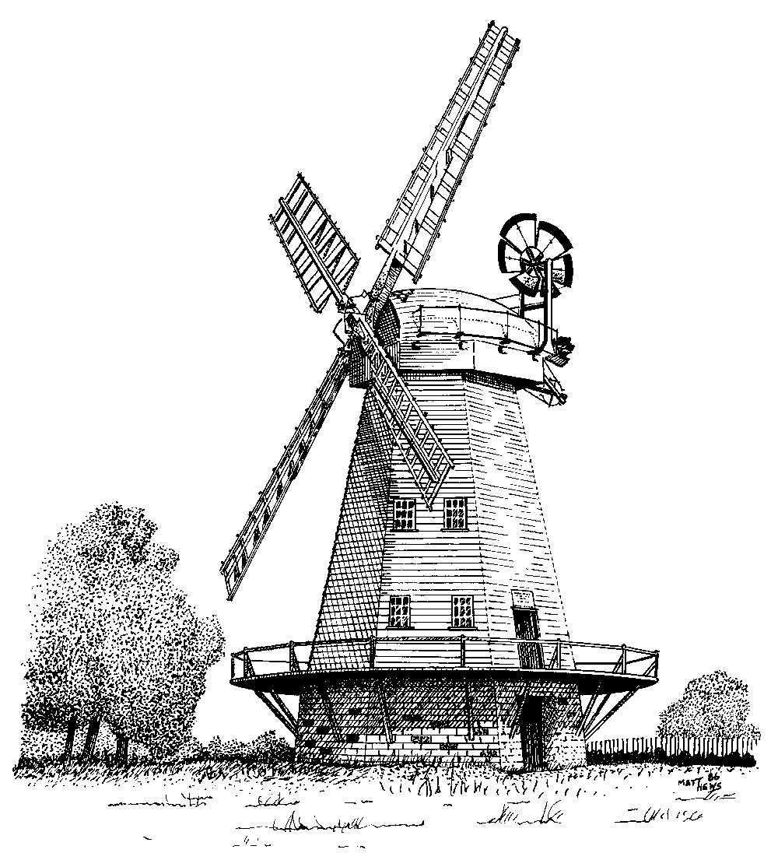
Friends of Upminster Windmill
http://www.upminsterwindmill.co.uk
Registered Charity Number 1097976
Chairman: Dennis Coombs, 1 Highview Gardens, Upminster RM14 2YU
Tel: 01708 221298 Email chairman@upminsterwindmill.co.uk

From Martin Withers, 40 Chelmer Road, Upminster RM14 1QT
01708 229564 vicechair@upminsterwindmill.co.uk

Updated 29 July 2026

Upminster Windmill 2014 OPEN DAYS

Please could you advertise our OPEN DAYS below:
Dates | April 5 & 6  19 & 20 Easter Weekend
Dates | May 3 & 4  10 & 11* National Mills Weekend  11th May * Craft Fair on the Mill Field  31st May Havering Mini Open House
Dates | June 7 & 8  21 & 22*  22nd June* Classic car show on the Mill field
Dates | July 5 & 6  19 & 20
Dates | August 2 & 3  16 & 17
Dates | September 6 & 7  20 & 21 London Open House Weekend
Dates | October 4 & 5
Time | 2.00pm to 5.00pm * Midday to 5.00pm
Event | Upminster Windmill Open Days and events
Organised By | The Friends of Upminster Windmill
Location | Mill Field, St. Mary’s Lane Upminster RM14 2QL
Details | The Friends of Upminster Windmill give visitors FREE conducted tours of this 200-year-old windmill, which has most of its original wooden machinery in place. On a windy day the sails and the cap can turn.  Please note that the stairs within the Mill are very steep, becoming almost ladder-like towards the top. Please wear sensible clothing and shoes. It is recommended that children are at least five years though younger children will be admitted to the upper floors provided they can climb and descend the stairways unaided and are under the close supervision of an adult.  All children 16 and under must be accompanied by an adult
Cost | FREE (donations are welcome)
Contact | Tel: 0300 030 1803 or www.upminsterwindmill.co.uk

Additional Events being arranged to be held on the Mill Field:
21st June and 2nd August: Film Nights
30th August: Possible a cultural event

